**Student Name: Jean Wilbert Volcy**

**Student ID: 986969**

**SafeAirlines: Use Case Diagram**

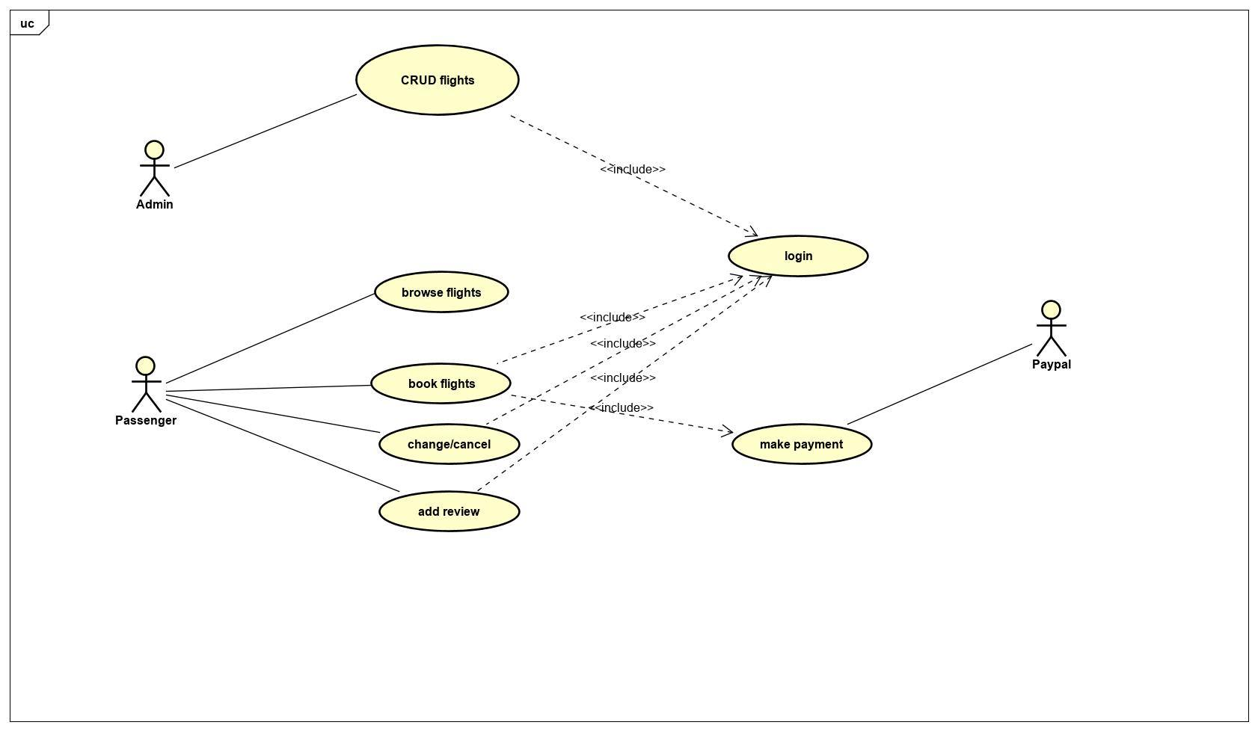

**SafeAirlines: Use Case Description**

|  |  |
| --- | --- |
| **Use Case Number: 1** | |
| **Name** | CRUD flights |
| **Brief description** | The use case allows admin to perform create, update,delete and read operations to manage flights. |
| **Actors** | Admin |
| **Preconditions** | |
| The admin must be logged in to the system | |
| **Flow of Events** | |
| **1. Basic Flow** | |
| **1.1.0.** Add flight schedule | |

|  |  |  |
| --- | --- | --- |
| **Step** | **User Actions** | **System Actions** |
|  | The admin click on the create flight schedule button. | The application displays the form with fields date, time, departure, destinations, seats etc. |
|  | The admin fill out the schedule details | The application shows all the flights available on entered date, time ,departure, destinations and airlines. If not available, display some message. |
| **Post Conditions** | | |
| The flight schedule is persisted in the system. | | |
| **Business Rules** | | |
| Each day flights are uniquely identified by flight number and time. | | |
| **1.1.1 Change flight schedule** | | |
| **Step** | **User Actions** | **System Actions** |
|  | The admin click the edit button to change the flight details. | Display the form with previously entered data. |
|  | Admin change the details required to be changed and submit submit button. | Redirects to the list of flight schedule page. |
| **Post Conditions** | | |
| The flight details changes is updated to the database. | | |
| **Business Rules** | | |
| No duplicate flight entry. | | |
| **1.1.2 Delete flight schedule** | | |
| **Step** | **User Actions** | **System Actions** |
|  | The admin click the delete button to change the flight details. | A dialogue messages appears to confirm delete. |
|  | Admin confirm and click the delete button. | Delete the flight data and redirect to the list of schedule page with. |
| **Post Conditions** | | |
| The flight details requested to delete is deleted from the database after successful deletion. | | |
| **Business Rules** | | |
| Passengers related to the deleted flight must be noticed and given an option to book other flights again. | | |

|  |  |
| --- | --- |
| **Use Case Number: 2** | |
| **Name** | Browse flights |
| **Brief description** | A user has the ability to browse all the available flights on the website without authentication |
| **Actors** | passenger |
| **Preconditions** | None |
| **Business Rule** | |
| None | |

|  |  |  |
| --- | --- | --- |
| **Brows flights** | | |
| **step** | **User actions** | **System Actions** |
| **1** | The user requests for a list of flights | The system returns a list of all flights. |
| **2** | The user selects to view a flight they want from the list | The system returns an object the wanted flight. |

|  |  |
| --- | --- |
| **Use Case Number: 3** | |
| **Name** | book flights |
| **Brief description** | A user has the ability to book a flight that he decides it the right one. |
| **Actors** | passenger |
| **Preconditions** | need the user to be authenticated. |
| **Basic Flows** | |
| 1. **Book flight**  |  |  |  | | --- | --- | --- | | **step** | **User actions** | **System actions** | | **1** | The user requests a flight | The system returns the specific flight | | **2** | The user selects a date, number of seats and type of class (first class or business class) | The system responds if the flight is available. | | **3** | The user provides his info. | The system returns a confirmation receipt. | | |
| **Business Rule** | |
| The flight must be available. | |

|  |  |  |  |
| --- | --- | --- | --- |
| **Use case Number #4** | | | |
| **Name** | | Edit Flight | |
| **Brief Description** | | This use case provides the manipulation a Passenger can make in a flight already booked. | |
| **Actors** | | Passenger | |
|  | | | |
| **Preconditions** | | | |
| The passenger needs to log first and also need to have a flight already booked. | | | |
| **Flows of Events** | | | |
| **1.Basic Flows** | | | |
| **1.0 Change** | | | |
| **Step** | **User Actions** | | **System Actions** |
| 1 | Passenger click on search flight | | The System return a box to enter the ID of the Receipt |
| 2 | Passenger Enter the Id of the Receipt | | the system returns the information about the ticket with the possibility of modifying them. |
| 3 | Passenger Enter new Date and click on save | | The system saves the information to the database. |
| **Post Condition** | | | |
| Book flight with a new Date | | | |
| **Business Rule** | | | |
| If the date Is too close with the current date, we need increase the price | | | |
|  | | | |
| **1.1 Cancel Flight** | | | |
| **Step** | **User Actions** | | **System Actions** |
| 1 | Passenger click on search flight | | The System return a box to enter the ID of the Receipt |
| 2 | Passenger Enter the Id of the Receipt | | the system returns the information about the ticket with the possibility of modifying them. |
| 3 | Passenger click on cancel | | The system cancel the flight and refund the money to the customer. |
| **Post Condition** | | | |
| No book flight for this receipt id | | | |
| **Business Rule** | | | |
| No | | | |
| **Use case Number #5** | | | |
| **Name** | | Feed back | |
| **Brief Description** | | After taking a flight the passenger should be able to give feed back to the flight so that the company can improve the quality of its service base on the requirement of its client. | |
| **Actors** | | Passenger | |
|  | | | |
| **Preconditions** | | | |
| The passenger needs to log first and also need to have a completed flight. | | | |
| **Flows of Events** | | | |
| **1.Basic Flows** | | | |
| **1.0 Add Feed back** | | | |
| **Step** | **User Actions** | | **System Actions** |
| 1 | Passenger click on search flight | | The System return a box to enter the ID of the Receipt |
| 2 | Passenger Enter the Id of the Receipt | | the system returns the information about the ticket with the possibility of modifying them. |
| 3 | Passenger click on add Feedback for this particular flight | | The system provides a text area to type some suggestions and some start to rate the flight. |
| 4 | After finish Passenger click on save bouton | | System save all the information to the database. |
| **Post Condition** | | | |
| No | | | |
| **Business Rule** | | | |
| No | | | |
|  | | | |
| **1.1 Delete Feed back** | | | |
| **Step** | **User Actions** | | **System Actions** |
| 1 | Passenger click on list flight | | The System return all the flight already taken by the Passenger |
| 2 | Passenger click on the feedback link | | The system returns the feed made by the Passenger for this specific flight |
| 3 | Passenger click on Delete and click on the save button. | | The system saves the information to the Database |
| **Post Condition** | | | |
| No | | | |
| **Business Rule** | | | |
| No | | | |
|  | | | |